FILE OPERATIONS – TASK 13

Task 13.1

package com.guvi.selenium;

import java.io.FileNotFoundException;

import java.io.FileOutputStream;

import java.io.OutputStream;

import org.apache.poi.hssf.usermodel.HSSFWorkbook;

import org.apache.poi.ss.usermodel.Workbook;

public class CreateBook {

public static void main(String[] args) throws FileNotFoundException {

// TODO Auto-generated method stub

Workbook wb = new HSSFWorkbook();

OutputStream obj = new FileOutputStream("testing.xlsx");

}

}

Output:

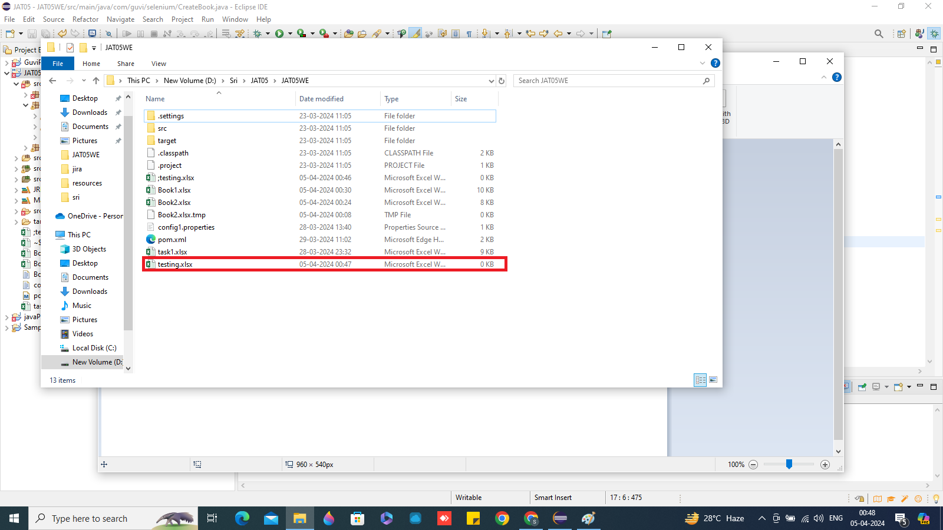

Task 13.2

**package** com.guvi.selenium;

**import** java.io.FileNotFoundException;

**import** java.io.FileOutputStream;

**import** java.io.IOException;

**import** java.io.OutputStream;

**import** org.apache.poi.hssf.usermodel.HSSFWorkbook;

**import** org.apache.poi.ss.usermodel.Sheet;

**import** org.apache.poi.ss.usermodel.Workbook;

**public** **class** CreateSheet {

**public** **static** **void** main(String[] args) **throws** FileNotFoundException, IOException {

// **TODO** Auto-generated method stub

Workbook wb = **new** HSSFWorkbook();

OutputStream obj1 = **new** FileOutputStream("testing2.xlsx");

Sheet sheet = wb.createSheet("Sheet 1");

System.***out***.println("Sheet has been created successfully");

wb.write(obj1);

}

}

Output:

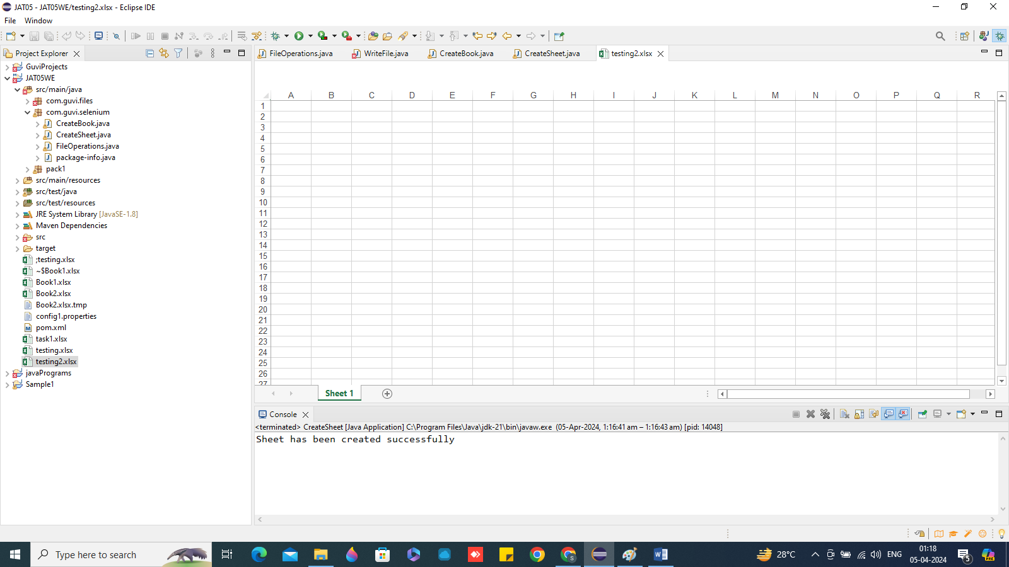

Task 13.3

package com.guvi.files;

import java.io.File;

import java.io.FileNotFoundException;

import java.io.FileOutputStream;

import java.io.IOException;

import org.apache.poi.xssf.usermodel.XSSFSheet;

import org.apache.poi.xssf.usermodel.XSSFWorkbook;

public class WriteFile {

public static void main(String[] args) {

// TODO Auto-generated method stub

WriteFile obj = new WriteFile();

String s2 = null;

try {

obj.excelWrite();

System.out.println(s2);

} catch (FileNotFoundException e) {

// TODO Auto-generated catch block

e.printStackTrace();

} catch (IOException e) {

// TODO Auto-generated catch block

e.printStackTrace();

}

System.out.println("End of program...");

}

public void excelWrite() throws FileNotFoundException, IOException {

File file = new File(System.getProperty("user.dir") + "\\Book2.xlsx");

FileOutputStream output = new FileOutputStream(file);

XSSFWorkbook book = new XSSFWorkbook();

XSSFSheet sheet = book.createSheet();

sheet.createRow(0).createCell(0).setCellValue("Name");

sheet.getRow(0).createCell(1).setCellValue("Age");

sheet.getRow(0).createCell(2).setCellValue("Email");

sheet.createRow(1).createCell(0).setCellValue("John Doe");

sheet.getRow(1).createCell(1).setCellValue(30);

sheet.getRow(1).createCell(2).setCellValue("john@test.com");

sheet.createRow(2).createCell(0).setCellValue("Jane Doe");

sheet.getRow(2).createCell(1).setCellValue(28);

sheet.getRow(2).createCell(2).setCellValue("john@test.com");

sheet.createRow(3).createCell(0).setCellValue("Bob Smith");

sheet.getRow(3).createCell(1).setCellValue(35);

sheet.getRow(3).createCell(2).setCellValue("jacky@example.com");

sheet.createRow(4).createCell(0).setCellValue("Swapnil");

sheet.getRow(4).createCell(1).setCellValue(37);

sheet.getRow(4).createCell(2).setCellValue("swapnil@example.com");

book.write(output);

book.close();

output.close();

}

}

Output:

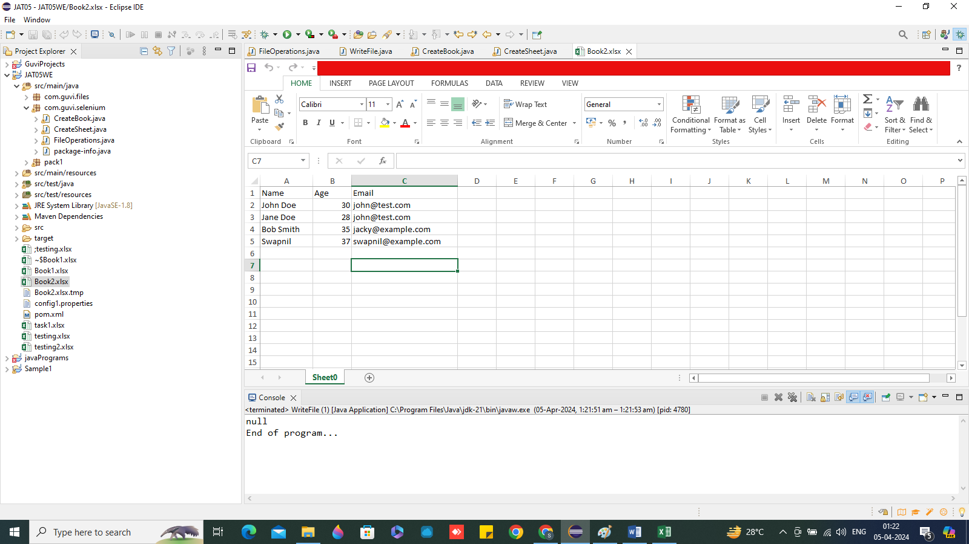

Task 13.4

**package** com.guvi.files;

**import** java.io.File;

**import** java.io.FileNotFoundException;

**import** java.io.FileOutputStream;

**import** java.io.IOException;

**import** org.apache.poi.xssf.usermodel.XSSFSheet;

**import** org.apache.poi.xssf.usermodel.XSSFWorkbook;

**public** **class** WriteData {

**public** **static** **void** main(String[] args) {

// **TODO** Auto-generated method stub

WriteData data = **new** WriteData();

String s3 = **null**;

**try** {

data.excelWrite();

System.***out***.println(s3);

} **catch** (FileNotFoundException e) {

// **TODO** Auto-generated catch block

e.printStackTrace();

} **catch** (IOException e) {

// **TODO** Auto-generated catch block

e.printStackTrace();

}

System.***out***.println("End of program...");

}

**public** **void** excelWrite() **throws** FileNotFoundException, IOException {

File file = **new** File(System.*getProperty*("user.dir") + "\\Book3.xlsx");

FileOutputStream output = **new** FileOutputStream(file);

///

XSSFWorkbook book = **new** XSSFWorkbook();

XSSFSheet sheet = book.createSheet();

sheet.createRow(0).createCell(0).setCellValue("Java");

sheet.getRow(0).createCell(1).setCellValue("Php");

sheet.getRow(0).createCell(2).setCellValue("Selemium");

sheet.getRow(0).createCell(3).setCellValue("testng");

sheet.createRow(1).createCell(0).setCellValue("laptop");

sheet.getRow(1).createCell(1).setCellValue("computer");

sheet.getRow(1).createCell(2).setCellValue("table");

sheet.getRow(1).createCell(3).setCellValue("wood");

sheet.createRow(2).createCell(0).setCellValue("manual");

sheet.getRow(2).createCell(1).setCellValue("automation");

sheet.getRow(2).createCell(2).setCellValue("red");

sheet.getRow(2).createCell(3).setCellValue("color");

book.write(output);

book.close();

output.close();

}

}

Output:

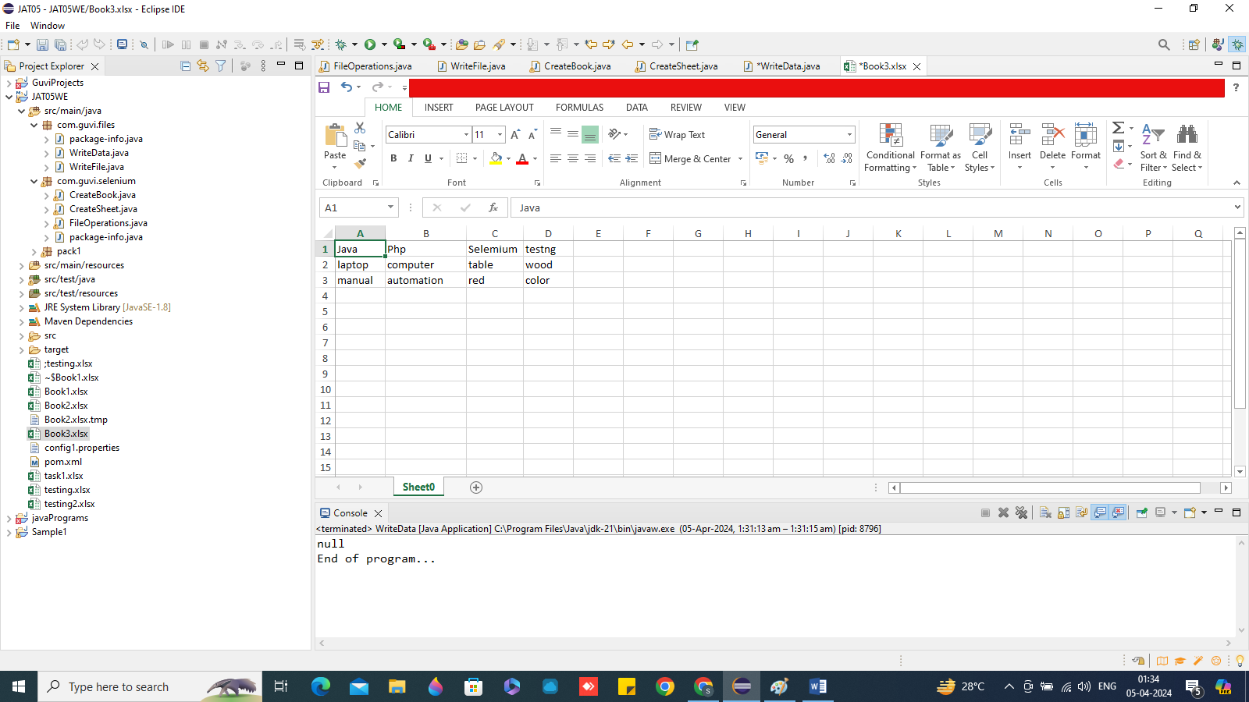

Task 13.5

package com.guvi.selenium;

import java.io.FileInputStream;

import java.io.FileNotFoundException;

import java.io.IOException;

import org.apache.poi.ss.usermodel.Cell;

import org.apache.poi.ss.usermodel.DataFormatter;

import org.apache.poi.ss.usermodel.DataFormatter;

import org.apache.poi.ss.usermodel.Row;

import org.apache.poi.xssf.usermodel.XSSFSheet;

import org.apache.poi.xssf.usermodel.XSSFWorkbook;

public class FileOperations {

public static void main(String[] args) {

// TODO Auto-generated method stub

FileOperations file = new FileOperations();

String s1 = null;

try {

s1 = file.excelRead("Book1", 1, 1);

System.out.println(s1);

} catch (FileNotFoundException e) {

// TODO Auto-generated catch block

e.printStackTrace();

} catch (IOException e) {

// TODO Auto-generated catch block

e.printStackTrace();

}

System.out.println("End of program...");

}

public String excelRead(String filename, int page, int c) throws FileNotFoundException, IOException {

String value = "";

FileInputStream input = new FileInputStream(System.getProperty("user.dir") + "\\" + filename + ".xlsx");

XSSFWorkbook book = new XSSFWorkbook(input);

XSSFSheet sheet = book.getSheetAt(page);

int last = sheet.getLastRowNum();

for (int i = 0; i <= last; i++) {

value = value + sheet.getRow(i).getCell(c) + " ";

}

book.close();

input.close();

return value;

}

}

Output:

tool php python set operations guvi learn

End of program...